**QUICK BASKET – A REFINED RETAIL EXPERIENCE**

Students: Adeeb Tahir R and Adithya R Ganesh

Guided by Mrs. S Sasirekha

Department of Information Technology

SSN College of Engineering, Anna University, Kalavakkam, Chennai 603110

[adeeb.tr@gmail.com](mailto:adeeb.tr@gmail.com) , [adithyarganesh@gmail.com](mailto:adithyarganesh@gmail.com)

***Abstract –*This report describes the idea, concept and run through of our efforts to solve one of retails prevalent issues: Queuing. ‘Quick Basket’ modularises the billing process making it more efficient for customers to purchase retail items without wasting much of their valuable time.**

1. INTRODUCTION

We as valuable customers have incredibly packed schedules and hence value time, perhaps more than any other factor when it comes to tasks such as shopping. Our patience is stupendously tested at the billing counter. A long arduous queue filled with angry customers or an unnecessary time lag isn’t everybody’s cup of tea. Our project focuses on considerably reducing this ‘waiting’. Let’s take it one step further and also say that we could possibly have an estimate of a customer’s possible expenditure!

With QUICK BASKET, we wish to bring an integrated solution to one of today’s prominent issues: Cloth Retail Billing Queues.

1. OBJECTIVE

The motivation behind QUICK BASKET came about when we were at one of our favourite departmental outlets ‘Lifestyle’. After grabbing what we needed, we paced to the billing counter and to our dismay: a LONG QUEUE! As we slowly made our way to the front of the line, we were discussing why not come up with a solution to this. We thought about somehow taking this billing process and speeding it up say by a factor of 10 and by this we mean that over 95% of your billing is already done the moment you drop an item in your basket/trolley. Thus, paved the way for our idea: QUICK BASKET!

1. PROPOSED SOLUTION

The solution [1] we envision is that the mainframe billing process be modularised, in other words, localised to a portable form which is situated at a convenient location, say one corner of a shopping basket or trolley. We will be working with a programmable Arduino UNO board whose code algorithms shall tend to:

* Multiple instance detection
* RF code detection
* Display (via LCD)

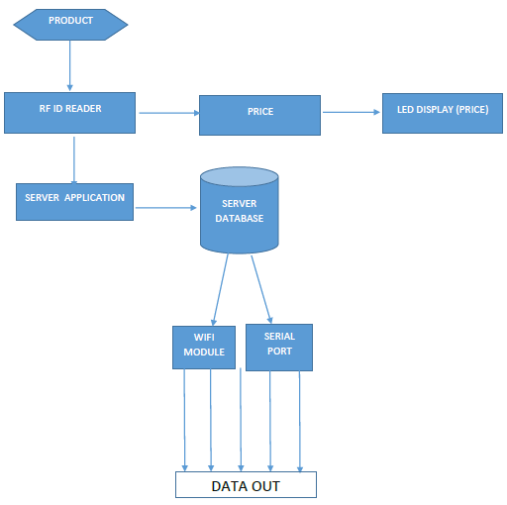This can be achieved through RF readers.

1.0 Flow Chart

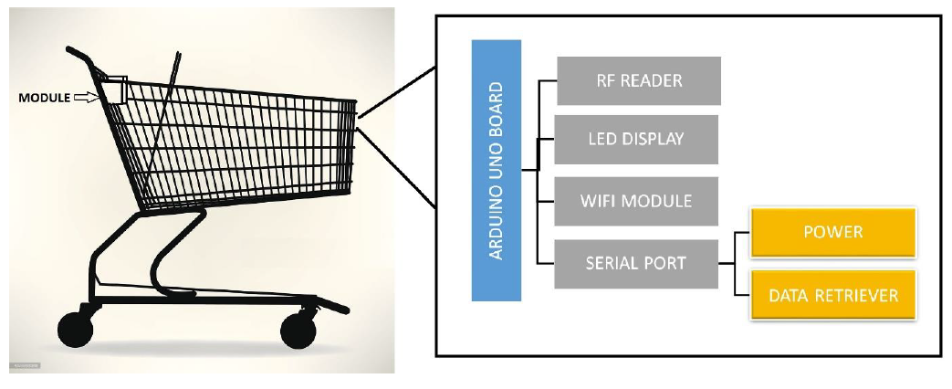

2.0 High level Model of quick Basket

1. COMPONENTS AND REQUIREMENTS

The various components that went into this project comprise the following [2] :

* Arduino UNO Board
* Board that facilitates all other appendages in our project, here. Programmable logic brings about necessary actions.
* RF Reader
* An RFID reader is a network connected device (fixed or mobile) with an antenna that sends power as well as data and commands to the tags. The RFID reader acts like an access point for RFID tagged items.
* Wi-Fi Module
* Enables wireless data retrieval and modification after customer approaches counter.
* Serial Port
* Power port to supply the Arduino with required power.
* USB Port
* Wired transmission in case of any network issue.
* LCD Display:
* To display the current amount payable.

The components are soldered and connected in the following manner:

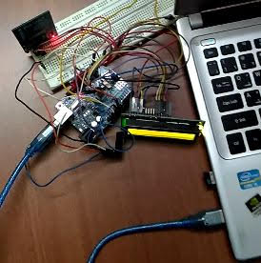

1. OBSERVATIONS

The following observations were successfully recorded [3] .Figure 3.0 and 3.1 shows the Serial monitor output and the LCD display outputs respectively:

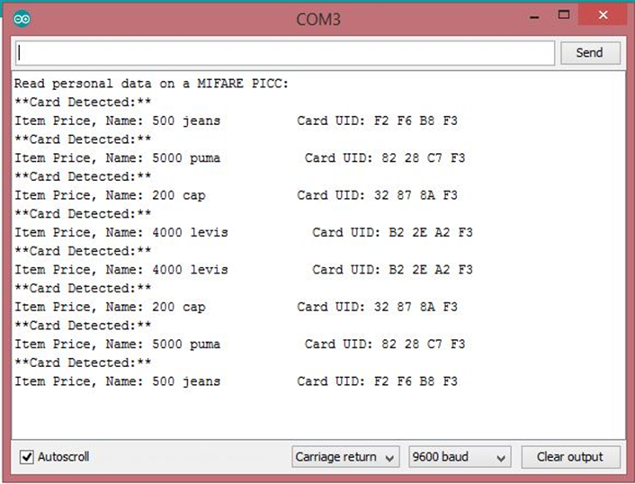

* 1. Serial Monitor Output

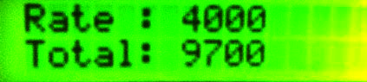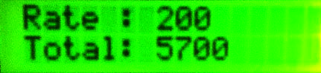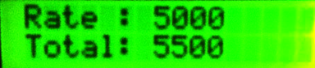

* 1. LCD Display Output

1. EXPERIMENTS AND RESULTS

Social Impact:

A better approach to buy products offline has been implemented that help both the general public and shops. [4] In our current fast paced world, it has become essential to make all our surroundings work at an increased rate. Customers now can manage their time efficiently. Now, we are looking for a cash free lifestyle with every mode of payment becoming more and more electronic. This leads to increased security and also one enables one to walk in and walk out of the store with nothing but their ID.

Summary of work:

A Quick Basket module with price update functionality created. The module can successfully detect an item when placed in the cart and immediately flashes the updated price inclusive of the rate of the item on the LCD display. When the same item is scanned again, the price is subtracted indicating that the item has been taken out of the basket. Further, any numeric errors such as negative pricing or bills have been eliminated with code constraints ensuring the price never drops below zero. The integration of web page data feed synchronized with the Wi-Fi module allows for easy visualisation of what a customer has and helps in managing their constraints such as budget.

1. CONCLUSIONS

In this report, we have addressed the problem of waiting in lines for buying clothes. All the connections have been soldered and tested. It was found that our model for a proposed solution works more or less well. The proposed software works well in real time. However, we are continuing this study with a much larger variety of items and with various other modules In addition, we also intend to improve the computational performance of our method by adding other important constraints to our module. The speed/accuracy of our system has provided us with positive results.

1. SCOPE FOR DEVELOPMENT

With further advancement in technology and scanning proficiency, this project could be extended to a more localised type of market like a grocery store where small items can also be embedded with RF tech.

1. REFERENCES
2. The TAB Book of Arduino – Simon Monk
3. Arduino Cookbook – Margolis
4. [www.electroschematics.com](http://www.electroschematics.com)
5. www.duino4projects